Frontcast – 1
CSS: Cascading Style Sheets
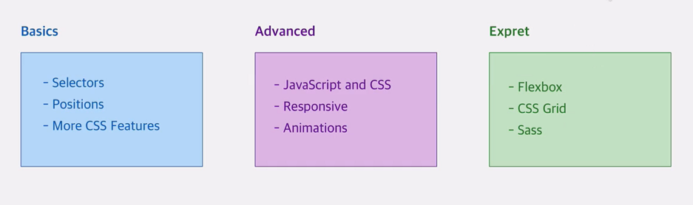

Frontcast – 2
https://developer.mozilla.org/en-US/docs/Web/CSS
Frontcast – 3
Tools:
IDE: vscode, sublime,…
Browser: Chrome
Frontcast – 4
Add Package Live server (extension)
1- Inline:
<section style="background: #1565c0">
2- style
<head>
<style>
section{
background: #1565c0;
}
</style>
</head>
به section در اصطلاح سلکتور میگیم .
3-file.css
در فایل html این قسمتواضافه میکنیم:
<link rel="stylesheet" href="styles/styles.css">
Frontcast – 6
Add font
یک فولدر داخل فولدر اصلی پروژه میسازیم با نام fonts , داخل css اینو استفاده میکنیم
@font-face {
font-family: "Vazir-FD-WOL";
src: url("../fonts//Vazir-FD-WOL.woff");
}

body{
direction: rtl;
font-family: "Vazir-FD-WOL";
}

فرق id و class: id یونیک هست و برای یک المنت استفاده میشه و براش # میذاریم, کلاس برای هر جایی که لازمه میتونه استفاده بشه و براش . میذاریم
Frontcast – 10
Inline Tag similar to <a>
Block Tag similar to <setion>
هر تگ بلاک یک مدل باکس داره 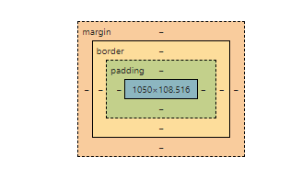
Frontcast – 14
هدر به قسمت بالا در هربلاک گفته میشود
Frontcast – 16
.main-nav{
width: calc(100% - 50px);
text-align:center;
display: inline-block;
}

Frontcast – 19
Pseudo classes and Pseudo elements
A CSS pseudo-element is a keyword added to a selector that lets you style a specific part of the selected element(s).
For example, ::first-line can be used to change the font of the first line of a paragraph. You can use only one pseudo-element in a selector. It must appear after the simple selectors in the statement.

/* The first line of every <p> element. */
p::first-line {
color: blue;
text-transform: uppercase;
}
In contrast to pseudo-elements, pseudo-classes can be used to style an element based on its state.

Syntax
selector::pseudo-element {
property: value;
}

::after (:after)
In CSS, ::after creates a pseudo-element that is the last child of the selected element. It is often used to add cosmetic content to an element with the content property. It is inline by default.
/* Add an arrow after links */
a::after {
content: "→";
}
- ::after (:after)
- ::before (:before)
- ::cue
- ::cue-region
- ::first-letter (:first-letter)
- ::first-line (:first-line)
- ::file-selector-button
- ::selection
- ::slotted()
- ::backdrop
- ::grammar-error
- ::marker
- ::part()
- ::placeholder
- ::spelling-error
- ::target-text

Pseudo-classes
A CSS pseudo-class is a keyword added to a selector that specifies a special state of the selected element(s). For example, :hover can be used to change a button's color when the user's pointer hovers over it.
/* Any button over which the user's pointer is hovering */
button:hover {
color: blue;
}

Linguistic pseudo-classes
These pseudo-classes reflect the document language, and enable the selection of elements based on language or script direction.
:dir
The directionality pseudo-class selects an element based on its directionality as determined by the document language.
:lang
Select an element based on its content language.

Location pseudo-classes
These pseudo-classes relate to links, and to targeted elements within the current document.
:any-link
Matches an element if the element would match either :link or :visited.
:link
Matches links that have not yet been visited.
:visited
Matches links that have been visited.
:local-link
Matches links whose absolute URL is the same as the target URL, for example anchor links to the same page.
:target
Matches the element which is the target of the document URL.
:target-within
Matches elements which are the target of the document URL, but also elements which have a descendant which is the target of the document URL.
:scope
Represents elements that are a reference point for selectors to match against.

User action pseudo-classes
These pseudo-classes require some interaction by the user in order for them to apply, such as holding a mouse pointer over an element.
:hover
Matches when a user designates an item with a pointing device, for example holding the mouse pointer over it.
:active
Matches when an item is being activated by the user, for example clicked on.
:focus
Matches when an element has focus.
:focus-visible
Matches when an element has focus and the user agent identifies that the element should be visibly focused.
:focus-within
Matches an element to which :focus applies, plus any element that has a descendant to which :focus applies.

Time-dimensional pseudo-classes
These pseudo-classes apply when viewing something which has timing, such as a WebVTT caption track.
:current
Represents the element or ancestor of the element that is being displayed.
:past
Represents an element that occurs entirely before the :current element.
:future
Represents an element that occurs entirely after the :current element.

Resource state pseudo-classes
These pseudo-classes apply to media that is capable of being in a state where it would be described as playing, such as a video.
:playing
Represents a media element that is capable of playing when that element is playing.
:paused
Represents a media element that is capable of playing when that element is paused.

The input pseudo-classes
These pseudo-classes relate to form elements, and enable selecting elements based on HTML attributes and the state that the field is in before and after interaction.
:autofill
Matches when an <input> has been autofilled by the browser.
:enabled
Represents a user interface element that is in an enabled state.
:disabled
Represents a user interface element that is in a disabled state.
:read-only
Represents any element that cannot be changed by the user.
:read-write
Represents any element that is user-editable.
:placeholder-shown
Matches an input element that is displaying placeholder text, for example from the HTML5 placeholder attribute.
:default
Matches one or more UI elements that are the default among a set of elements.
:checked
Matches when elements such as checkboxes and radiobuttons are toggled on.
:indeterminate
Matches when UI elements are in an indeterminate state.
:blank
Matches a user-input element which is empty, containing an empty string or other null input.
:valid
Matches an element with valid contents. For example an input element with type 'email' which contains a validly formed email address.
:invalid
Matches an element with invalid contents. For example an input element with type 'email' with a name entered.
:in-range
Applies to elements with range limitations, for example a slider control, when the selected value is in the allowed range.
:out-of-range
Applies to elements with range limitations, for example a slider control, when the selected value is outside the allowed range.
:required
Matches when a form element is required.

:optional
Matches when a form element is optional.
:user-invalid
Represents an element with incorrect input, but only when the user has interacted with it.

Tree-structural pseudo-classes
These pseudo-classes relate to the location of an element within the document tree.
:root
Represents an element that is the root of the document. In HTML this is usually the <html> element.
:empty
Represents an element with no children other than white-space characters.
:nth-child
Uses An+B notation to select elements from a list of sibling elements.
:nth-last-child
Uses An+B notation to select elements from a list of sibling elements, counting backwards from the end of the list.
:first-child
Matches an element that is the first of its siblings.
:last-child
Matches an element that is the last of its siblings.
:only-child
Matches an element that has no siblings. For example a list item with no other list items in that list.
:nth-of-type
Uses An+B notation to select elements from a list of sibling elements that match a certain type from a list of sibling elements.
:nth-last-of-type
Uses An+B notation to select elements from a list of sibling elements that match a certain type from a list of sibling elements counting backwards from the end of the list.
:first-of-type
Matches an element that is the first of its siblings, and also matches a certain type selector.
:last-of-type
Matches an element that is the last of its siblings, and also matches a certain type selector.
:only-of-type
Matches an element that has no siblings of the chosen type selector.

Frontcast – 26
برای section حتما id میدیم که منحصر بفرد باشه.
Frontcast – 33
.clearfix{
clear: both;
}

از این کلاس داخل div استفاده میکنیم تا بین دو بلاک فضای مورد نظر رو ایجاد کنه و بلاکها توهم نباشن
Frontcast – 34
برای حرکت منو همراه با اسکرول:
position: fixed;

نسبت به المنت قبلی فیکس در نظر گرفته میشه
top: 0;
left: 0;
فاصله از بالا و چپ

Frontcast – 36
z-index: -1;
اولویت قرار گرفتن المنتها بترتیب اول -1 بعد 0
Frontcast – 37
Add Badge:
Frontcast – 47
filter
Frontcast – 49
در طراحی ریسپانسیو برای font-size از em rem و % استفاده میکنیم.
Px مقدار ثابت میدهد
تفاوت em rem :
مقدار rem به خود فونت سایز مرورگر بستگی داره ولی em به پرنت بستگی داره
1rem = 16px
برای مارجین و پدینگ هم بهتره از rem استفاده کنیم که ریسپانسیو باشه .
Frontcast – 52
viewport
برای عرض از vw و برای ارتفاع از vh استفاده میکنیم و شبیه % عمل میکند اما بر اساس ویوپورت.
Frontcast – 55
Change styles with javascript
<script src="./scripts/shared.js"></script>
این خط و دستورات جاوا اسکریپت رو قبل از تگ </body> میذلریم
Frontcast – 59
<meta name="viewport" content="width=device-width" ,initial-sclae=1.0>
این خط برای ساپورت سایت بر اساس دیوایس است استاندارد طراحی بر اساس mobile first است . برای اینکار :
Frontcast – 61 Media Query
وقتی max-width میاریم desktop first میشه و وقتی Min-width میاریم mobile first میشه . از سایت https://www.mydevice.io/ میتونیم سایزها رو بگیریم

#overview {
width: 100vw;
height: 30vh;
background: linear-gradient(rgb(212, 211, 211), rgb(128, 127, 127)) no-repeat
fixed center/cover;
}

@media(min-width : 40rem) {
#overview{
height: 50vh;
}
}

